Modeling Viral Videos
EECS 372 – Agent Based Modeling – Northwestern University
Jeanette Pranin
Introduction and Motivation
The phenomenon of viral videos has emerged relatively recently in our history on the Internet: according to Bodnar (2010), the first viral video on YouTube appeared in 2005 and was watched more than 5 million times before being taken down. Despite its relatively new appearance in our modern world, viral videos have taken the Internet by storm, with thousands of videos garnering millions of views each year. But how and why does this phenomenon arise? What are the aspects of the video, the social world, and the people that contribute to the popularity of videos? Are there additional seemingly unrelated variables that contribute to a video’s success? These are the questions among others that I will explore in this model.
This model is a good fit for ABM because it is easy to define and vary parameters of both the videos and the social networks watching the videos. The people sharing the videos will also generally follow consistent behaviors that can be modeled with turtle commands; if one has shared a video on Facebook this week, it is likely that one will have shared a video on Facebook before and will again in the future – vice versa, if one has never shared a video, it is not likely for one to share unless under extraneous circumstances, which can be produced at random by the code.
Watching viral videos is not only a favorite pastime of many people across the world, but it is also the source of a new type of advertising. There are several advertising agencies, one such called Unruly, whose sole purpose is to create viral video campaigns for their clients. Unruly specifically looks at several components such as the different types of emotions elicited by videos (inspiration, sadness) as well as the social motivations of the watcher (opinion-seeking, conversation-starting). This advertising technique is becoming a multi-billion dollar industry, so finding out what makes a video viral is increasingly becoming a lucrative business.
The goals of this project are to recreate rates of sharing found through research pertaining to the social and non-social discovery of viral videos (Broxton et al. 2013) and analyze what conditions of the model, including the people, videos, and networks, contribute to these results.
Background Work
Although no one knows the exact formula that makes a video go viral, there have been several studies that have analyzed the characteristics of viral videos and the contexts in which they were shared most.
Broxton et al. (2013) discusses how the social and non-social discovery of videos contributes to a video’s popularity. A social discovery of a video simply means that someone shared the video to someone else, while a non-social discovery of a video is the finding of a video unintentionally, such as watching a video in the Related Videos section on YouTube (Broxton et al. 2013). They found that the socialness of videos varied by category, as detailed by the table below, I utilized the rates found in the “Highly Shared Video %” and compared them to the rates of sharing produced by the current model to these rates.
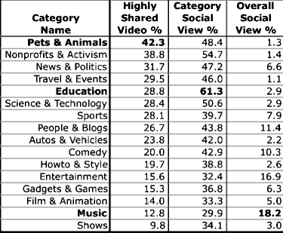
Figure 1: Figure 5 of Broxton et al.’s “Catching a Viral Video.” The “Highly Shared Video %” column contains values used in this Modeling Viral Videos model.
Keeping this in mind, I will attempt to replicate these rates in the current model. I represent the social or non-social discovery of a video based on how close related videos are to each other (e.g. animal videos are spatially near other animal videos). This will be discussed further in my design.
Guadagno et al. (2013) examines the influence of the way in which stories are portrayed in videos (i.e. what points of the video are emphasized) as well as the source of the video (i.e., who shared it, a friend, acquaintance, or enemy). They found that video content had a significant effect in the number of times a video was forwarded and that Cute and Funny videos were more likely to be shared than Disgusting or Angry videos. However, there was no main effect for video source. Because Guadagno et al. (2013) did not find a significant effect from the source of the video; accordingly, I did not include groups of people in the current model. Although they did find a significant effect of the emotion of the video, the emotions described in the paper such as happiness and sadness were so broad that I decided to express the emotions elicited in the forms of social motivations, described below.
Referring back to Unruly, the advertising agency posits that there are nine different types of social motivations, or reasons behind why people share videos: Shared Passion, Social IRL, Social Utility, Social Good, Zeitgist, Kudos, Reaction Seeking, Self-Expression, and Shared Emotional Experience (Siverd 2013). These characteristics are rated on a 1 to 5 scale and averaged to create an overall social motivation score. The higher the score, the more likely the video will trigger the psychological response of sharing the video. Instead of the broad emotions of happiness and sadness described by Guadagno et al., I will utilize this social motivation score in my design of the video agents. I believe this is an appropriate substitution because the mood of the person (happiness, sadness, etc.) affects their motivation in sharing or not sharing a video.
Model Design
The model represents turtles as people, patches as videos, and links as networks.
Construction
People
Each person has a list of videos they have seen previously, the chance that this person will share a video, whether they recommend the current video they are watching, the last person who recommended a video to them, and the number of times they have shared a video so far.
Videos
Each video has the number of times it has been viewed, the type of video it is (Animals, Activism, Politics, Travel, Education, Science, Sports, People, Autos, Comedy, Howto, Entertainment, Games, Film, Music, Shows), a unique video ID, the last person who shared it, and its social motivation rating list (Shared Passion, Social IRL, Social Utility, Social Good, Zeitgeist, Kudos, Reaction Seeking, Self-Expression, Shared Emotional Experience). The social motivation list is initialized to be a list of length 9 with each item having a random number from 1 to 5 in it.
Networks
Networks are represented by links with weights that indicate the strength of the relationship between people. There are three types of networks: random, preferential, and small-world.
Agent and System Behavior
A network first connects people to each other. If it is a random network, then there is a 10% chance that a person is connected to another person. If it is a preferential network, people are more likely to be connected with people who have numerous connections. If it is a small-world network, a person is no more than six degrees of separation away from another person.
The world itself is organized into blocks: The top left of the world have the more frequently shared types of videos (Animal Videos are red, Activism videos are orange) while the bottom left of the world have the less frequently shared video types (Music videos are dark gray, Show videos are white).
People then “watch” the video represented by the patch that they are currently on. The more a video is watched, the darker the patch becomes (when it has a high number of views it reverts back to a lighter color). If a person watches the video and likes it enough to share (which is computed by their own likelihood of sharing, the rate of sharing of the video-type as described by Broxton et al., and the social motivation score of the video), they will recommend the video to their network. They will then find a new video to watch by taking the recommendation of their most influential neighbor, or the person with which they have the heaviest weighted link. If they have seen this video before, there is a 50% chance they will watch it again. If they watch the video and they like it, they will share the video and strengthen the connection between them and the recommender of the video by increasing the link weight between them by 1. Otherwise, they will move to a related video by moving to a nearby patch.
Every (deletion-rate) number of ticks, (chance-of-deletion) percent of the videos is deleted in order to simulate new videos being uploaded. Deletion-rate and chance-of-deletion are values determined by sliders.
Motivation Behind Implementation
Networks are the way in which I implemented the social discovery of videos as described by Broxton et al. (2013). In the current model, videos are recommended across these networks just as people share videos on social media sites such as Facebook or Twitter to their social network in real life. The world is organized into colored blocks in order to simulate the Broxton’s non-social discovery of videos, as videos that are related to each other and that you may find in the YouTube Related Videos box are placed spatially near each other.
The chance that a single person will share a video depends on the rate of which that type of video is shared (Broxton 2013), the person’s own propensity to share (a random percentage from 0% to 100%), and the video’s social motivation score (Siverd 2013).
The recommending attribute of turtles reflects the idea that a person will sometimes watch a video that they do not like and will therefore not forward it on.
I also implemented the recommendation algorithm in such a way that the recommendation of the person with the heaviest link is the video that one decides to watch. The more you like the videos a person shares to you, the stronger your connection becomes. This simulates the fact that you are most likely to watch a video sent to you by someone that has a big impact on you, whether that is a close friend or a celebrity. The more videos you share and like between each other, the stronger the influence of that person becomes.
Model Output
Below are figures detailing the visual output of each type of network as well as plots generated by the current model of the rates of sharing.
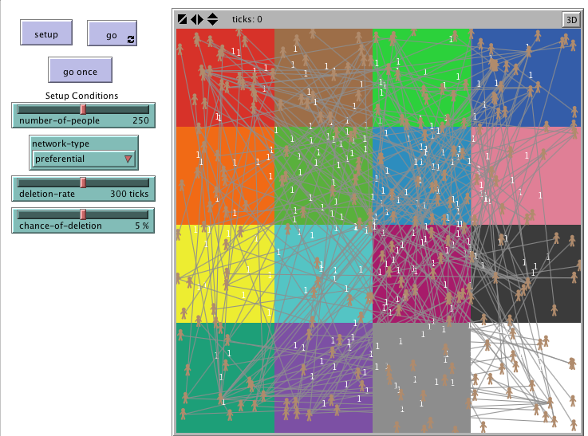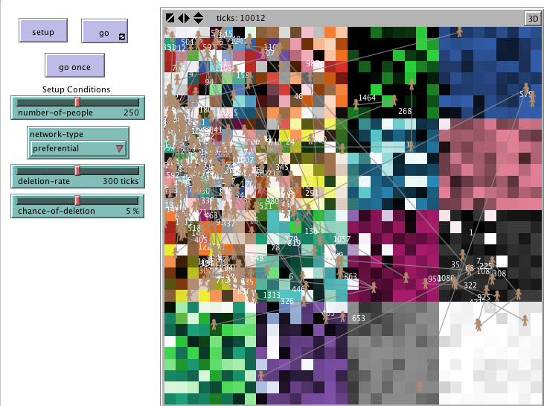
Figure 2: Preferential network at initialization on the left and after 10,000 ticks on the right. Notice how the density of the network is low as compared to the other network types upon initialization. Notice the spread of the videos watched after 10,000 ticks. The rates of sharing plotted in the graph are very similar to the rates found by the Broxton paper.
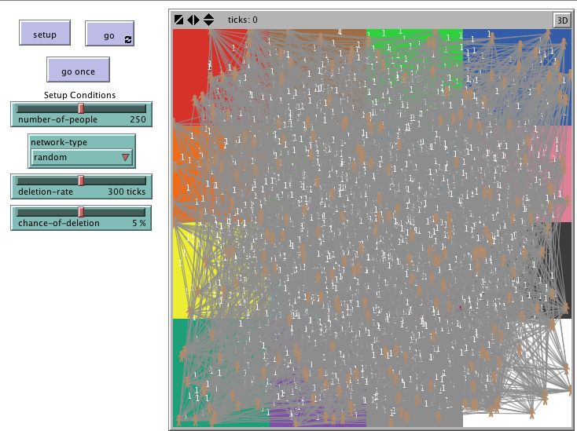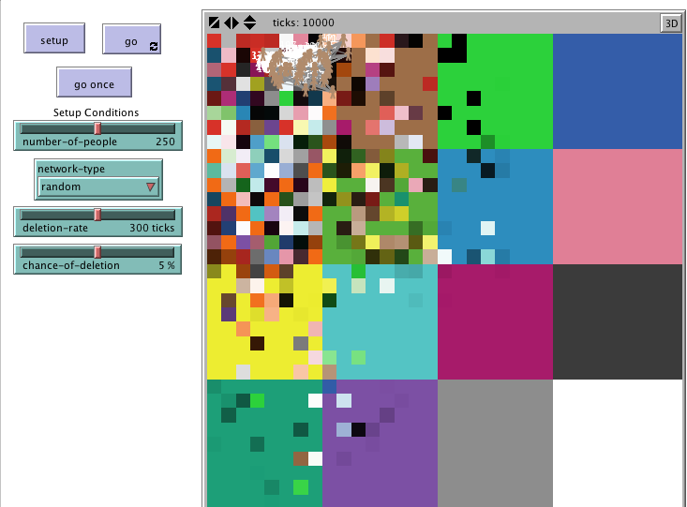
Figure 3: Random network at initialization on the left and after 10,000 ticks on the right. Notice how the density of the network is much higher compared to the preferential network upon initialization. The spread of the videos watched is much smaller and the rates of sharing based on video type are not the same values nor in the same order as those in the Broxton paper after 10,000 ticks.
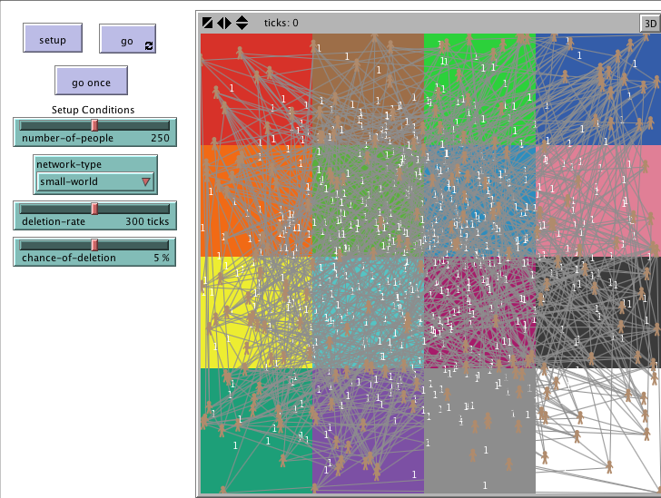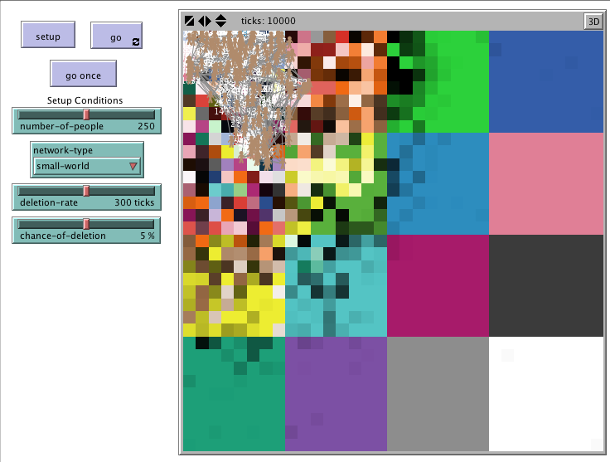
Figure 4: Small-world network at initialization on the left and at 10,000 ticks on the right. The density is higher than that of the preferential network but lower than that of the random network upon initialization. The spread is in between that of the preferential network and the random network after 10,000 ticks. The rates of sharing by video type do not correspond exactly to the Broxton paper, but the order in which video-types are shared is the same.
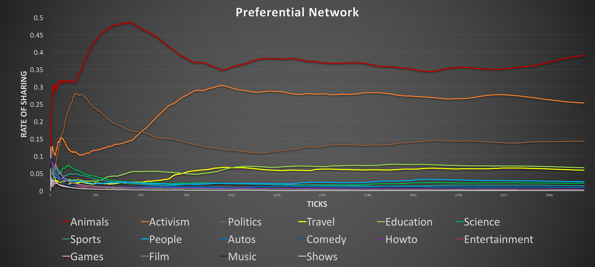
Figure 5: Rates of Sharing on a Preferential Network
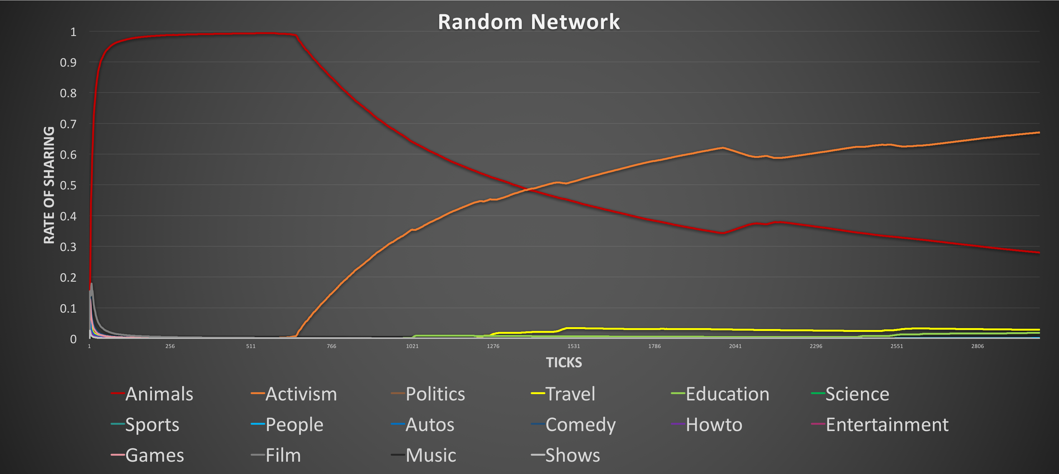
Figure 6: Rates of Sharing on a Random Network
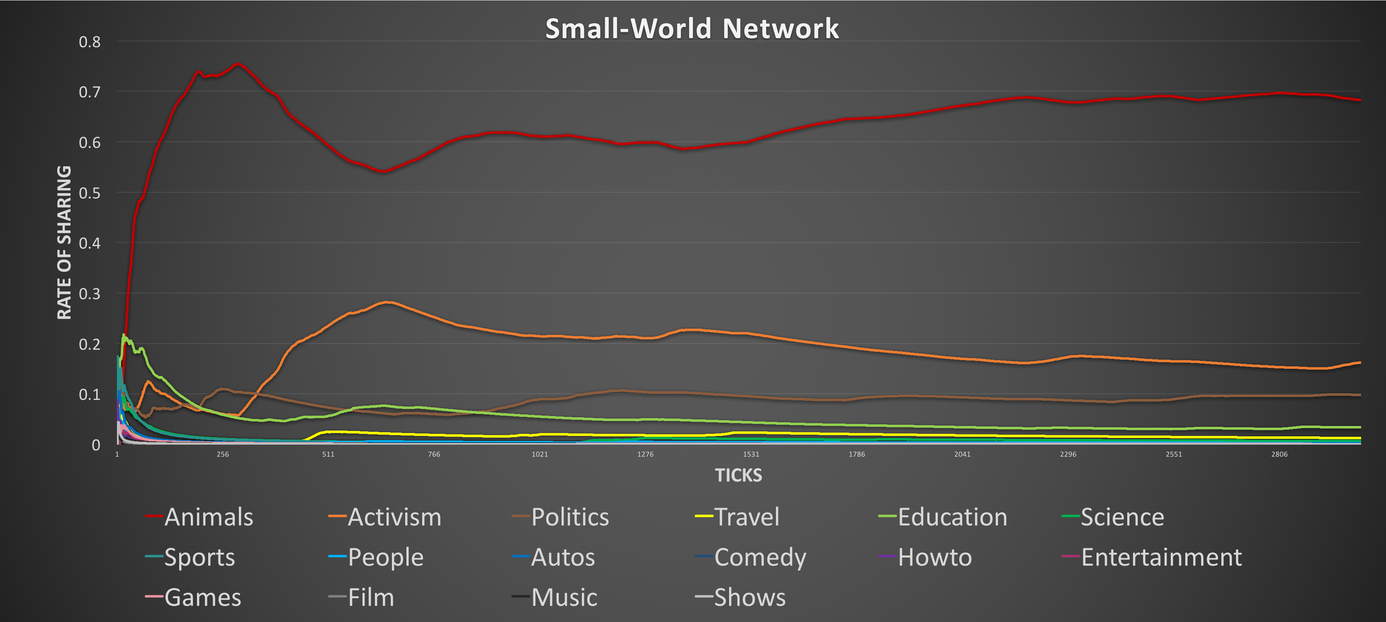
Figure 7: Rates of Sharing on a Small-World Network
Model Analysis
The results suggest that the Preferential network best recreates the rates found in the Broxton et al. paper (Figure 1). The Broxton rate of Animal videos was 42.3%, and the Preferential rate hovered slightly below 40%. The Broxton rate of Activism videos was 38.8% , and the Preferential rate hovered around 30%, and so on and so forth.
The Random network did not come close to replicating Broxton’s results, as the Activism videos were ultimately shared more than the Animal videos and the rest of the video types were barely shared at all. The results seemed to depend heavily on the initial configuration of the model.
The Small-world network performed better than Random but worse than Preferential: the rates were significantly off – Animals were shared about 65% of the time, Activism videos about 20%, etc. – but the order of video-type based on popularity was the same as that of Broxton – Animal videos were viewed more than Activism videos which were viewed more than Politics videos, and so on.
Although Behavior Space experiments were performed on other attributes such as deletion-rate and number-of-people, the network-type by far had the biggest impact. These data support the idea that videos are made viral through a preferential network. Although content is important, the channels in which the video is shared has a bigger impact. If the content of a video speaks to one person in a preferential network, it is more likely to be shared with more people who may potentially like it as well. This finding may be critical to those who wish to create a viral video in the future.

Conclusion and Future Work
There are several limitations of the current model that can be addressed in future iterations. Firstly, in order to model more realistic networks, people who have similar interests – e.g. like inspirational videos more than funny videos – should be connected to and have heavier links between each other. The same can be done with videos: videos with similar social motivation ratings can be closer in proximity to each other. Secondly, the effect of when influential people who set trends through social media, who are often celebrities, share a video may also have a significant impact on how popular it becomes. This person’s influence may also impact how popular related videos become. These and other questions can and should be explored in the future.
Although there may never be a formula to creating the perfect viral video, more and more companies are getting close. Advertising agencies like Unruly are analyzing the different behaviors of the people sharing the video and the characteristics of the video itself to see what contributes to the popularity of a video, and they claim they are nearing 80% accuracy in predicting whether a video will go viral (Moore 2013). In the ever-changing billion-dollar advertising industry, unlocking the secret of viral videos to create successful viral video campaigns really can be a game-changer, so exploring the behavior of this and other similar models may very well be a worthy investment.
References
Bodnar, Kipp. “Happy 5th Anniversary to Youtube’s First Viral Video.” HubSpot (2010).
Broxton, Tom, et al. “Catching a viral video.” Journal of Intelligent Information Systems 40.2 (2013): 241-259.
Guadagno, Rosanna E., et al. “What makes a video go viral? An analysis of emotional contagion and Internet memes.” Computers in Human Behavior 29.6 (2013): 2312-2319.
Moore, Gregory. “The Holy Grail of Viral Video: ‘Shareability’?. Overdrive Interactive (2013).
Siverd, Veronica. “Data Scientists Show Music Makes Video More Shareable.” JustGo.com (2013).
Wilensky, U. (1999). NetLogo [computer software]. Evanston, IL: Center for Connected Learning and Computer-Based Modeling, Northwestern University. http://ccl.northwestern.edu/netlogo .
Wilensky, U. Head, B. & Payette, N. (2012). NetLogo Networks Extension. Evanston, IL: Center for Connected Learning and Computer Based Modeling, Northwestern University. http://ccl.northwestern.edu/netlogo/docs/nw.html .
Wilensky, U., & Shargel, B. (2002). BehaviorSpace [Computer Software]. Evanston, IL: Center for Connected Learning and Computer Based Modeling, Northwestern University. https://ccl.northwestern.edu/netlogo/docs/behaviorspace.html .

